Statement of Work

Grainger PLC
Salesforce - Rent Smart Wales

Version 1.0
September 22, 2023
Contents
1 Statement of Work 3
1.1 Summary 3
1.2 high level Requirements 3
1.3 References 4
1.4 Project Objectives 4
1.5 Delivery Approach 5
1.6 Responsibilities 5
1.7 Project Administration 6
2 Exclusions & Limitations 8
3 Cost and timelines 9
4 Go-Live and Support 10
5 Acceptance 11

Statement of Work

Summary
Grainger PLC have new building units becoming available for rent in Wales. Salesforce needs to be configured to account for the Welsh rental terms, conditions, and contract clauses.
The following Statement of Work (SOW) describes the development work required to update Grainger PLC’s Salesforce org to account for these changes.

high level Requirements
# | Rating/ Priority | User Story
1 | Must Have | As a TPT User, I want to generate an Occupation Contract from an Opportunity for a Welsh property, so that the document can be sent out to be signed
2 | Must Have | As a TPT User, I want to send an occupation Contract to all Contract Holders, so that they can sign the document online.
3 | Must Have | As a Lettings User, I want the Agreement Type to be occupation Contract for all opportunities in Wales, so that an incorrect document cannot be sent
4 | Must Have | As a Grainger User, I want any communication sent to an opportunity for a Welsh property to have the correct Welsh terminology, so we adhere to Rent Smart Wales legislation
5 | Must Have | As a Grainger User, I want any communication sent to an account that is currently living in a Welsh property to have the correct Welsh terminology, so we adhere to Rent Smart Wales legislation
6 | Must Have | As a potential Contract Holder, I want to see a draft Occupation Contract before signing, So I can review the standard terms
7 | Must Have | As a potential Contract Holder, I want to view the Terms and Conditions of renting a property with Grainger prior to starting the process, So I am aware of the terms and conditions.
8 | Must Have | As a potential Contract Holder, I want to see all the correct Rent Smart Wales terminology throughout the customer journey, so that I know what I am being asked for
9 | Must Have | As a Grainger User, I want any communications sent to a lead that is for a Welsh property to have the correct Welsh terminology, so we adhere to Rent Smart Wales legislation
10 | Nice to Have | As a TPT User, I want to be prevented from sending the occupation Contract prior to the previous tenant vacating the home, so that the contract cannot be signed by either party in the event that the notice is rescinded
11 | Must Have | As a Lettings User, I want the potential Contract Holder to be notified that their let is dependent on the previous tenant moving out and that the current resident can rescind notice, so they are aware that the documents may come later than expected
12 | Nice to Have | As a Grainger User, I want to initiate the COS process upon request from a tenant, so that documents can be sent electronically and automatically

Table 1: High-level requirements

References
- Requirements Outline - 15.09.2023.xls.
- Rent Smart Wales Context.msg received 20.09.2023.
- Meeting with Yvonne Dargavel, Jacob Smycz, Jonathan Hyde, Sam Duncan & Shaun Barrett on 20.09.2023.
- Rent Smart Wales: Requirements Meeting recording.

Project Objectives
Open Box will engage with key Grainger PLC stakeholders to:
- Unpack the high-level requirements to capture detailed functionality on Jira.
- Develop the required changes in Salesforce as per table 1 above.
- Prioritize the user stories on the backlog in collaboration with Grainger PLC that will deliver the functionality required for release 1.
- Complete QA testing and deploy changes to Grainger PLC UAT environment for end-to-end testing by Grainger PLC.
- Deploy changes to Grainger PLC PROD environment on successful completion of UAT.

Delivery Approach
The delivery approach will be based on the SCRUM framework. Iterative delivery is achieved through a series of 3-week sprints.
An agile delivery approach allows for the early delivery of outcomes and provides flexibility to adjust for any unforeseen opportunities or issues uncovered during the project.
A backlog will be maintained to track outcomes to be delivered and indicate priority of these outcomes relative to each other. The backlog will be a living artifact that will evolve as Open Box and Grainger PLC collaborate towards maximizing the value delivered. Grainger PLC stakeholders will have access to the backlog which will serve as the single source of truth with regards to scope.
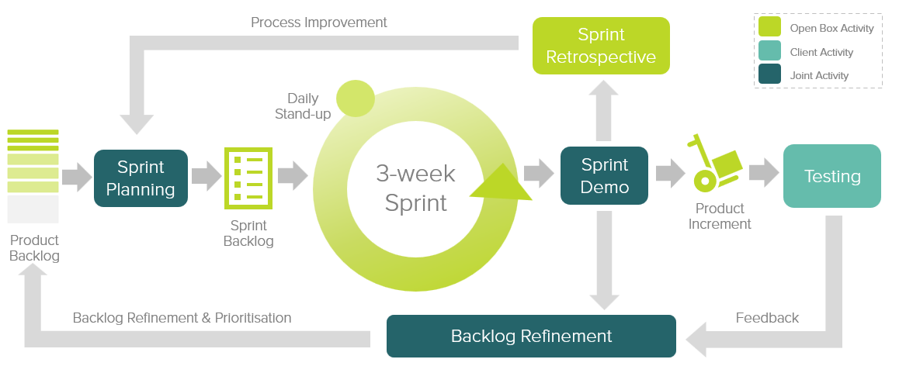
Figure 1: 3-week sprint process
Grainger PLC representatives will be required to particulate in the required sprint ceremonies, as they are in the End of Tenancy project.

Responsibilities

Open Box will:
- Complete the Project Objectives detailed above.
- Provide prompt review and feedback to questions and comments from Grainger PLC.
- Make the necessary personnel available during the project as and when required, ensuring no delays occur through all phases, per scheduling set forth in Cost and Timelines and in full compliance with the Agreement.
- Provide project deliverables on-schedule and respond timeously to Grainger PLC feedback in accordance with the mutually agreed upon acceptance procedure.

Grainger PLC are responsible for:
- Providing access to the necessary Salesforce environments and other connected applications
- Making the necessary personnel available during the project as and when required, providing timely input through the various phases. Timing commitments cannot be guaranteed by Open Box if Grainger PLC personnel are not made available to the project.
- Providing prompt review, feedback and sign-off of project deliverables in accordance with the mutually agreed upon acceptance procedure.
- Involving the correct level of stakeholder representation during the various phases of the project.
- Providing all available supporting documentation as requested from time to time by Open Box.

Project Administration
- Resources will be contactable on email and available for meetings via conference or video calls.
- Project resources will be available Monday to Friday 9am – 6pm South African Time (GMT +02:00) excluding public holidays.
- A defined escalation path will be provided to the agreed project manager should urgent assistance be required outside of these times.
- Open Box will provide a regular report to the agreed Grainger PLC project manager which includes:
  - Overall project health.
  - Project risks.
  - Project milestones and timeline.
  - All other details required by Grainger PLC throughout the project, which will include, at a minimum, all details sufficient for Grainger PLC to assess project progress and timeliness under the agreed schedule.

Exclusions & Limitations
The following is not included in the cost or scope of this project:
- Travel or on-site resources as all work will be performed remotely.
- End-user training, change management and adoption.

Cost and timelines
Open Box resources are costed on a day rate of £630 per day.

This project is being delivered in an agile methodology, as a result requirements are not fully defined and therefore effort and cost may change.

Should additional work be required to deliver any of the above items or other requirements that arise during the course of the project, this will be undertaken at the day rate of £630 for a commitment of 5 or more consecutive days, or a T&M rate of £116 / hour if less than this. Any work performed on this basis will be estimated beforehand and will require prior approval from Grainger PLC and agreement on impact to timelines.

Below is a break-down of the project phases and estimated duration & costs:

Project Phases | Duration (Weeks) | Effort (Days) | Estimated Cost
Sprint 0: Initial Analysis & backlog creation | 1 | 3 | £1,890
Sprint 1: Development & QA | 3 | 18 | £11,340
UAT | 1 | 2.5 | £1,575
Production Support | 1 | 2.5 | £1,575
Total | 6 | 26 | £16,380

This project required the following roles to ensure successful delivery:
- Salesforce Technical Architect
- Salesforce Developer
- QA Tester
- Project Manager

Project costs will be billed monthly, in arrears.

This project is expected to start the week of 9th October.

Go-Live and Support
- The Open Box project team will provide post go-live support for 1 week (5 working days) following the production deployment. This support is limited to issues that are classified as bugs and does not cover changes and/or enhancements.
- Following the post go-live support period, bugs and/or enhancements will be fixed or addressed by Open Box on a time and materials basis at £116 / hour. All work completed on this basis will first be estimated by Open Box and will require prior approval from Grainger PLC.

Acceptance
The parties hereto, each acting under due and proper authority, have executed this Agreement as of the day, month and year first written below.
For and on behalf of  Open Box Software |  |  | For and on behalf of  Grainger PLC
Signature: |  |  | Signature:
Name: | Sam Duncan |  | Name: | Paul Glibbery
Position: | Director of Salesforce |  | Position: | CIO
Date: |  |  | Date:

